Press Release

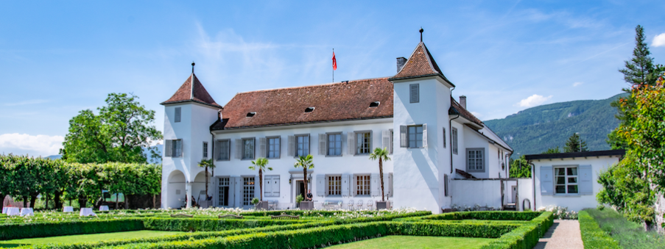

Top 50 W.A. de Vigier Award
W.A. de Vigier Foundation Increases Prize Money

Solothurn, February 15, 2022 The foundation behind Switzerland’s oldest startup award is increasing the prize money by CHF 100,000: this year, the W.A. de Vigier Foundation will award up to six young Swiss entrepreneurs with prizes of CHF 100,000 each. On February 17, 50 startups will enter the race for the prestigious awards. The startups will pitch their ideas on Selection Day via a public live stream on www.devigier.ch.

"From out of approximately 200 applications, we have selected 50 startups that meet our high quality standards. We are pleased to livestream the pitches of these exciting companies to the public and in this way, to offer the startups a broader reach and great visibility," says Carmen Lamparter, COO of the W.A. de Vigier Foundation.

Seven industry clusters represented

The wide range of industries represented is also exciting: Life Sciences/Biotech & Pharma, Cleantech, Medtech, ICT, Micro- & Nanotechnology, Services, and Interdisciplinary companies. Each startup is assigned to one of these seven industry clusters and will have three minutes to present its project. After the event, the jury will select its Top 15, which will be further evaluated in the following weeks. From these Top 15, the ten best are then selected. The finalists will present their companies at the Award Ceremony on June 22, 2022.

About the W.A. de Vigier Awards

The W.A. de Vigier Award is the oldest award for young entrepreneurs in Switzerland and, with annual prize money of up to CHF 600,000 (six times CHF 100,000), is one of the most highly endowed startup prizes in Switzerland. Over the past 33 years, the foundation has distributed over CHF 11 million of seed money. The results are about 100 flourishing startups, successful IPOs, multiple company exits and above all, many newly created jobs.
The following aspects are relevant for the evaluation of the projects: The entrepreneurial personality, the degree of innovation, the value for society as a whole, the technical and financial viability, market prospects and the potential for job creation.

###

Contact details for questions
W.A. de Vigier Foundation
Carmen Lamparter, COO
Untere Steingrubenstrasse 25 | 4500 Solothurn | +41 79 799 55 28
carmen.lamparter@devigier.ch | www.devigier.ch

