Press Release

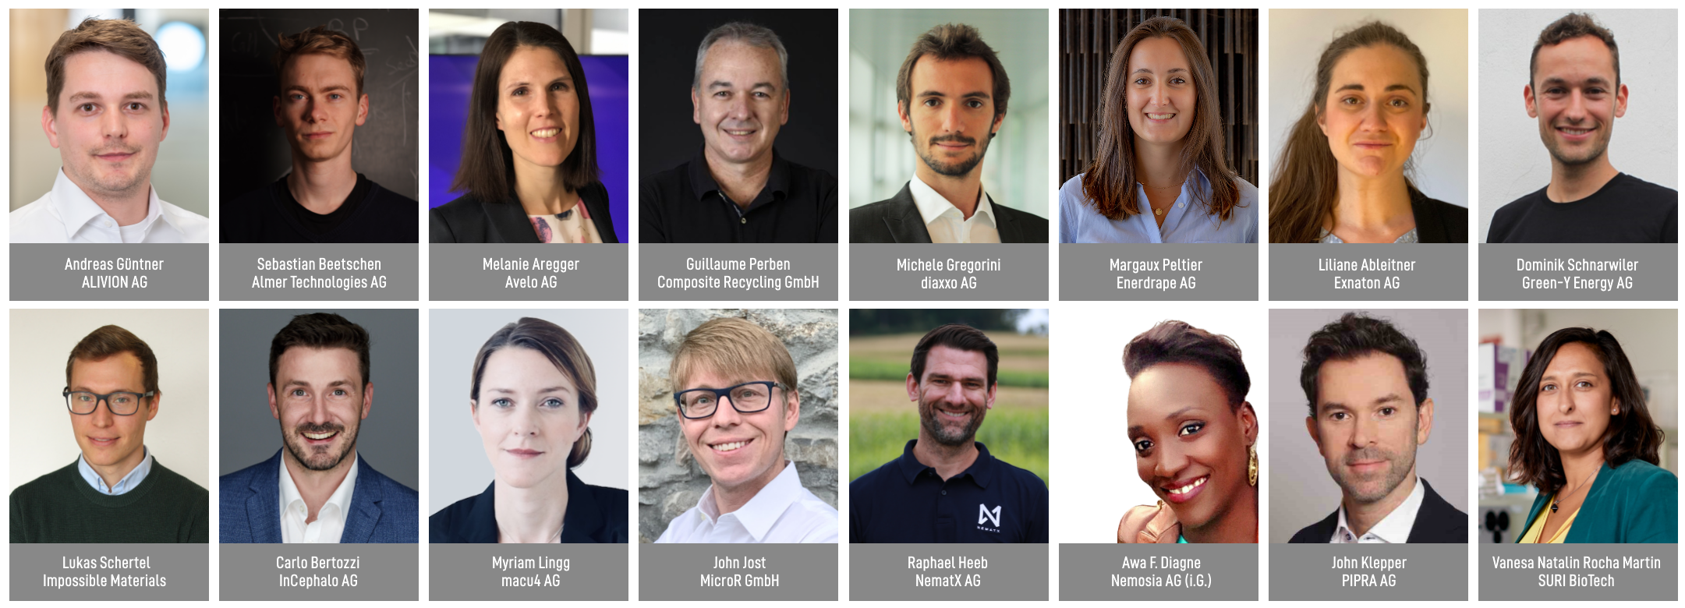

W.A. de Vigier Awards 2022
16 Startups Advance to the Next Round

Solothurn, March 24, 2022 16 startups are one lap further in the race for up to six coveted W.A. de Vigier Awards. The startups were selected from among 50 young companies who presented their ideas to the foundation board, and to numerous online viewers on Selection Day in mid-February. Up to six Swiss entrepreneurs will receive CHF 100,000 each at the award ceremony on June 22, 2022.

On Selection Day on February 17, the Top 16 were chosen from among 50 pre-selected startups. A total of over 200 applications were submitted.

"We were impressed with the pitches as well as the number of online viewers“, says Carmen Lamparter, COO of the W.A. de Vigier Foundation. „Over 550 viewers watched the pitches live online, we are very pleased to offer these startups the opportunity to pitch in front of such a specific and highly engaged audience“, continues Lamparter.

The Top 16 will now be further assessed through in-depth interviews with the foundation board as well as expert reports. The Top 10 are subsequently selected during two presentation days. In the second half of April, the ten finalists will be chosen and are going to present their highly innovative ideas at the award ceremony on June 22, 2022.

These are the Top 16 (in alphabetical order)

ALIVION AG from Menzingen (ZG) – Equipping Electronics With a Sense of Smell
Today’s electronic devices can do many things, but they can’t taste or smell. The available laboratory instruments are are bulky and expensive, while gas sensors cannot distinguish harmful from harmless molecules. ALIVION provides mobile chemical sensing devices that can trace single molecules by leveraging its revolutionary Molecule Select (TM) technology based on breakthroughs in nanotechnology at ETH Zürich. The portable gas sensors offer great value in the areas of healthcare (breath analysis), environmental monitoring, occupational and food safety through the detection of relevant molecules.

Almer Technologies AG from Bern (BE) - Augmented Reality Remote Assistance
If production breaks down in a factory and an expert has to fly in to fix the problem, that is expensive and emits a lot of CO2. Almer Technologies provides an all in one solution with its compact AR glasses and hardware accelerated software. This allows companies to effortlessly support frontline workers across the globe from any location, as if the expert was standing in the same room. That leads to less downtime for production, less cost for travel time and expenses, and less travel-related CO2 emission.

Avelo AG from Schlieren (ZH) –Saving Lives With Breath Aerosol Diagnostics
Diagnosing lower respiratory tract infections causing pneumonia and Tuberculosis is neither easy nor reliable. Avelo makes every breath count with its breath collector. This non-invasive and novel tool enables doctors to collect a patient’s breath sample at the point-of-care and analyze it with existing PCR tests. With the results doctors can select the right treatment, better manage the patient in their office, and only refer severe cases to the hospital. This improves patient outcomes, saves healthcare costs, and avoids unnecessary prescription of antibiotics.

Composite Recycling GmbH from Ecublens (VD): Closing the Loop on Composites Recycling
Composite materials are made by combining fibers with resin and are used to build boats, wind turbine blades, etc. They are strong, light, durable, but up to now not recyclable, and are thus piling up in landfills and incinerators at exponential rates. In partnership with the Advanced Composite Lab of the EPFL, this startup has developed a sustainable solution to separate the glass fibers from the resin of composites waste and reuse them to make new composites. No more toxic gases from incineration, no more landfilling, but rather “closing the loop” by reusing these versatile materials again and again.

diaxxo AG from Zurich(ZH) - Rapid and affordable PCR-based HPV testing
Cervical cancer, mainly caused by HPV infection, is the second most common cancer among women and a leading cause of cancer-related deaths in low- and middle-income countries, where screening tests and treatments are not readily available. diaxxo’s rapid PCR test provides high-quality diagnostics for HPV in less than 30 minutes and at an affordable cost. This solution could be the key to establishing widespread screening in low- and middle-income countries, which could significantly reduce the mortality rate.

Enerdrape AG from Lausanne (VD) – Turning Underground Structures Into Thermal Energy Sources
Solutions for heating and cooling buildings in a sustainable way are limited in scalability and access, while energy professionals and building owners are under pressure to meet political/corporate, economic and sustainability metrics. EPFL spinoff Enerdrape developed modular, easy to install and scalable geothermal panels that capture renewable heat from new or existing underground environments. Their solution looks great, can lower CO2 emissions by up to 80% and cuts down energy bills by up to 60%.

Exnaton AG from Zurich (ZH) – Software for Renewable Energy Communities
It has never been more evident that our society needs to switch to renewable energy as fast as possible. Our B2B2C platform PowerQuartier empowers utility companies to offer new services around renewables to their own customers - private households and businesses. Our first use case is the introduction of energy communities in which one can buy green electricity directly from their neighbors who own solar systems. This makes investing in renewable energy easy and fun for end users while our algorithms handle dynamic billing of complex energy flows for utility companies in the background. Customers in four countries trust the solution, which is also integrated into SAP.

Green-Y Energy AG from Hasle bei Burgdorf (BE) – Profitable, Clean and Efficient Energy Storage System
Current solutions for the storage of renewable energy are expensive and contain hazardous materials. The compressed air technology by Green-Y Energy stores electricity and provides renewable heat and cold, all in one decentralized device, using only air and water as working fluids. This solution significantly reduces costs and offers eco-friendly, highly profitable electricity storage.

Impossible Materials from Fribourg (FR) – Plant-Based White Pigments That Aren’t Cancerogenic
Titanium dioxide is used as a white pigment in paints, inks, cosmetics, pharmaceuticals, and food. However, this ingredient poses health and environmental hazards and is being banned in food. Fribourg based startup Impossible Materials develops patented, brilliantly white pigments from cellulose - a material that is renewable, widely available, cheap, biocompatible, and easy to process. The company’s pigments can be scaled with industry-proven processes, are safe for humans and don’t harm the planet.

InCephalo AG from Allschwil (BL) – Treating Aggressive Brain Tumors With Less Side Effects
One problem when treating brain diseases is that less than 1% of the IV administered drugs actually make it to the brain. Even when applied directly into the brain, these biological drugs rapidly leave the brain and start accumulating in the body. Incephalo's compartment locked technology (CLock) creates for the first time tailor-made biological drugs for local treatment of the brain. The CLocked drugs stay in the desired compartment, and if they leak, they are rapidly degraded. This significantly reduces the drugs’ overall exposure to the body and allows for a higher local dosing window.

macu4 AG from Zurich (ZH) - 3D Printing Affordable and Customized Forearm Prosthetics
More than 20 million people worldwide are missing a limb. Most do not have access to affordable and/or quality prosthetics. This is especially difficult for children, because as they grow, they frequently need a replacement. The Zurich based startup’s software designs customized forearm prosthetics that can be 3d printed at affordable prices. The design is lightweight, modular and suitable for activities that matter to people.

MicroR GmbH from Lausanne (VD) – Lasers to Provide Ultra High Data Rates
Data centers are reaching their limit. We need new solutions to enable faster and more energy-efficient ways to transmit the exploding amount of data, while lowering costs. MicroR developed multicolor lasers for high-capacity data transmission and optical computing based on a technology called “microcombs“. One microcomb can replace hundreds of high-quality lasers used in today’s optical communications while being up to 10x more energy efficient and enabling 30x higher data transmission rates at the same device size.

NematX AG from Zurich (ZH) – High-Performance Polymer 3D Printing
Specialized markets ranging from electronics to aerospace require high-performance polymer components in small batches. The production of such parts is associated with high costs today and make the small series business for many companies unprofitable. ETH spinoff NematX offers an industrial 3D printing solution based on novel liquid crystal polymers including a tailored manufacturing technology to combine highest part performance and manufacturing precision in polymer 3D printing. Customers benefit from up to 80% lower costs, three times faster delivery times, and fully recyclable materials.

Nemosia AG from Winterthur (ZH) – Early Diagnosis of Neurodegenerative Diseases
The best chance at fighting neurodegenerative diseases it is to detect them and intervene as early as possible. Nemosia’s PET neuroimaging solution is able to detect such disorders already at the sub-clinical stage, plus it supports researchers in developing and monitoring therapies. Reduced diagnostic time, effective drug development and personalized treatments are just a few advantages this technology can bring to our aging society.

PIPRA AG from Zurich (ZH) – AI-Based Test to Assess Risk of Cognitive Disorders After Surgery
Postoperative delirium (POD) is a severe cognitive complication occurring in 20% of surgical patients aged 60+. There are no treatments once symptoms arise. Instead, the focus is on prophylactic interventions, which are too costly to offer every patient. PIPRA developed an AI-based preoperative risk prediction software that identifies patients who are most at risk and will benefit from targeted prophylactic intervention, thereby improving patient outcomes and saving costs for hospitals.

SURI BioTech from Zurich (ZH) – A solution for colic babies and their parents’ wellbeing
Infant Colic (IC) affects up to 20% of babies from birth and up to four months of age. Colic babies cry inconsolably for hours, which causes significant suffering and stress for them and their families. SURI BioTech, an ETH start-up, developed BactoKind, a consortium of bacterial strains that impacts the metabolism of the gut microbiome, reducing gas production, bloating, and associated pain in crying babies. This solution gives colic babies a much happier start to life and improves the wellbeing of their caregivers.

About the W.A. de Vigier Awards

The W.A. de Vigier Award is the oldest award for young entrepreneurs in Switzerland and, with annual prize money of up to CHF 600,000 (six times CHF 100,000), is one of the most highly endowed startup prizes in Switzerland. Over the past 33 years, the foundation has distributed over CHF 11 million of seed money. The results are about 100 flourishing startups, successful IPOs, multiple company exits and above all, many newly created jobs.
The following aspects are relevant for the evaluation of the projects: The entrepreneurial personality, the degree of innovation, the value for society as a whole, the technical and financial viability, market prospects and the potential for job creation.

###

Contact details for questions
W.A. de Vigier Foundation
Carmen Lamparter, COO
Untere Steingrubenstrasse 25 | 4500 Solothurn | +41 79 799 55 28
carmen.lamparter@devigier.ch | www.devigier.ch

