Press Release

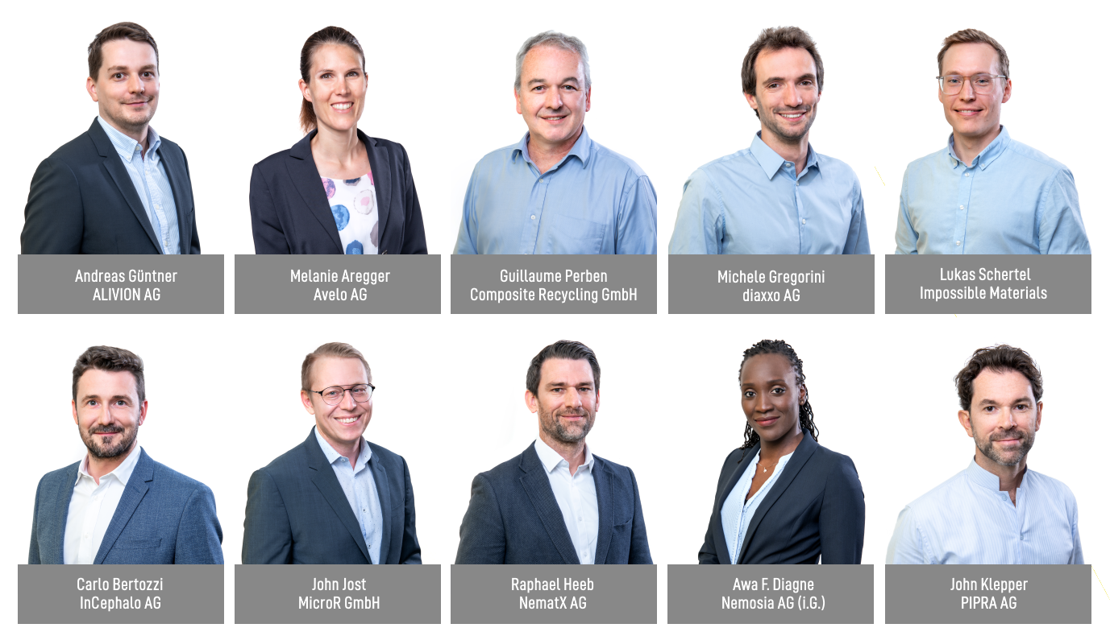

W.A. de Vigier Awards 2022
Ten Nominees to Be Greeted by the CEO of Roche

Solothurn, May 31, 2022. This year’s Award Ceremony on June 22 will be special in many ways: There will be up to six instead of up to five prizes, it’s the first year lead by the new leadership team Hanna Byland and Carmen Lamparter, and the keynote speaker will be Severin Schwan, the CEO of Roche. The jury recently chose the final ten nominees for a W. A. de Vigier Award, each endowed with CHF 100,000.00.

„Our jury was very impressed by the CEOs and their presentations, which made picking ten highly promising startups across five industry clusters all the more challenging“, says Carmen Lamparter, COO of the W.A. de Vigier Foundation.

From over 200 submitted projects, the jury picked their Top 16 in February. The 16 CEOs went through an interview process and presented their ideas to the Foundation Board, who now chose the final ten nominees. On June 22, up to six of those young leaders will receive a W. A. de Vigier Award, each endowed with CHF 100,000.00. The 2022 award ceremony will be opened by André Hoffmann, President of the Foundation, this year’s keynote speaker is Dr. Severin Schwan, the CEO of Roche.

These are the Top 10 (in alphabetical order)

ALIVION AG from Menzingen (ZG) – Equipping Electronics With a Sense of Smell
Today’s electronic devices can do many things, but they can’t taste or smell. The available laboratory instruments are bulky and expensive, while gas sensors cannot distinguish harmful from harmless molecules. ALIVION provides mobile chemical sensing devices that can trace single molecules by leveraging its revolutionary Molecule Select™ technology based on breakthroughs in nanotechnology at ETH Zürich. The portable gas sensors offer great value in the areas of healthcare (breath analysis), environmental monitoring, occupational and food safety through the detection of relevant molecules.

Avelo AG from Schlieren (ZH) –Saving Lives With Breath Aerosol Diagnostics
Diagnosing lower respiratory tract infections causing pneumonia and Tuberculosis is neither easy nor reliable. Avelo makes every breath count with its breath collector. This non-invasive and novel tool enables doctors to collect a patient’s breath sample at the point-of-care and analyze it with existing PCR tests. With the results doctors can select the right treatment, better manage the patient in their office, and only refer severe cases to the hospital. This improves patient outcomes, saves healthcare costs, and avoids unnecessary prescription of antibiotics.

Composite Recycling GmbH from Ecublens (VD): Closing the Loop on Composites Recycling
Composite materials are made by combining fibers with resin and are used to build boats, wind turbine blades, etc. They are strong, light, durable, but up to now not recyclable, and are thus piling up in landfills and incinerators at exponential rates. In partnership with the Advanced Composite Lab of the EPFL, this startup has developed a sustainable solution to separate the glass fibers from the resin of composites waste and reuse them to make new composites. No more toxic gases from incineration, no more landfilling, but rather “closing the loop” by reusing these versatile materials again and again.

diaxxo AG from Zurich(ZH) - Rapid and affordable PCR-based HPV testing
Cervical cancer, mainly caused by HPV infection, is the second most common cancer among women and a leading cause of cancer-related deaths in low- and middle-income countries, where screening tests and treatments are not readily available. diaxxo’s rapid PCR test provides high-quality diagnostics for HPV in less than 30 minutes and at an affordable cost. This solution could be the key to establishing widespread screening in low- and middle-income countries, which could significantly reduce the mortality rate.

Impossible Materials from Fribourg (FR) – Plant-Based White Pigments That Aren’t Cancerogenic
Titanium dioxide is used as a white pigment in paints, inks, cosmetics, pharmaceuticals, and food. However, this ingredient poses health and environmental hazards and is being banned in food. Fribourg based startup Impossible Materials develops patented, brilliantly white pigments from cellulose - a material that is renewable, widely available, cheap, biocompatible, and easy to process. The company’s pigments can be scaled with industry-proven processes, are safe for humans and don’t harm the planet.

InCephalo AG from Allschwil (BL) – Treating Aggressive Brain Tumors With Less Side Effects
One problem when treating brain diseases is that less than 1% of the IV administered drugs actually make it to the brain. Even when applied directly into the brain, these biological drugs rapidly leave the brain and start accumulating in the body. InCephalo's compartment locked technology (CLock) creates for the first time tailor-made biological drugs for local treatment of the brain. The CLocked drugs stay in the desired compartment, and if they leak, they are rapidly degraded. This significantly reduces the drugs’ overall exposure to the body and allows for a higher local dosing window.

MicroR GmbH from Lausanne (VD) – Lasers to Provide Ultra High Data Rates
Data centers are reaching their limit. We need new solutions to enable faster and more energy-efficient ways to transmit the exploding amount of data, while lowering costs. MicroR developed multicolor lasers for high-capacity data transmission and optical computing based on a technology called “microcombs“. One microcomb can replace hundreds of high-quality lasers used in today’s optical communications while being up to 10x more energy efficient and enabling 30x higher data transmission rates at the same device size.

NematX AG from Zurich (ZH) – High-Performance Polymer 3D Printing
Specialized markets ranging from electronics to aerospace require high-performance polymer components in small batches. The production of such parts is associated with high costs today and make the small series business unprofitable for many companies. ETH spinoff NematX offers an industrial 3D printing solution based on novel liquid crystal polymers including a tailored manufacturing technology to combine highest part performance and manufacturing precision in polymer 3D printing. Customers benefit from up to 80% lower costs, three times faster delivery times, and fully recyclable materials.

Nemosia AG from Winterthur (ZH) – Early Diagnosis of Neurodegenerative Diseases
The best chance at fighting neurodegenerative diseases it is to detect them and intervene as early as possible. Nemosia’s PET neuroimaging solution is able to detect such disorders already at the sub-clinical stage, plus it supports researchers in developing and monitoring therapies. Reduced diagnostic time, effective drug development and personalized treatments are just a few advantages this technology can bring to our aging society.

PIPRA AG from Zurich (ZH) – AI-Based Test to Assess Risk of Cognitive Disorders After Surgery
Postoperative delirium (POD) is a severe cognitive complication occurring in 20% of surgical patients aged 60+. There are no treatments once symptoms arise. Instead, the focus is on prophylactic interventions, which are too costly to offer every patient. PIPRA developed an AI-based preoperative risk prediction software that identifies patients who are most at risk and will benefit from targeted prophylactic intervention, thereby improving patient outcomes and saving costs for hospitals.

About the W.A. de Vigier Awards

The W.A. de Vigier Award is the oldest award for young entrepreneurs in Switzerland and, with annual prize money of up to CHF 600,000 (six times CHF 100,000), is one of the most highly endowed startup prizes in Switzerland. Over the past 33 years, the foundation has distributed over CHF 11 million of seed money. The results are about 100 flourishing startups, successful IPOs, multiple company exits and above all, many newly created jobs.
The following aspects are relevant for the evaluation of the projects: The entrepreneurial personality, the degree of innovation, the value for society as a whole, the technical and financial viability, market prospects and the potential for job creation.

###

Contact details for questions
W.A. de Vigier Foundation
Carmen Lamparter, COO
Untere Steingrubenstrasse 25 | 4500 Solothurn | +41 79 799 55 28
carmen.lamparter@devigier.ch | www.devigier.ch

