Press Release

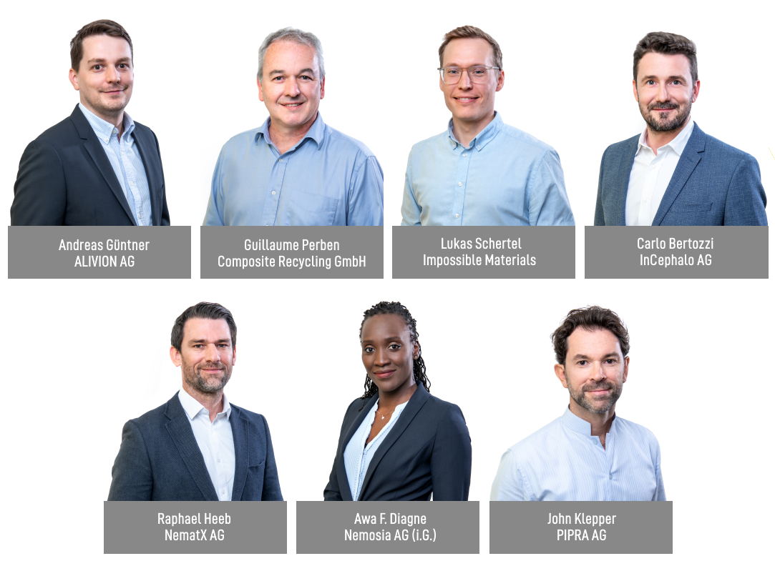

W.A. de Vigier Awards 2022
7 Startups Receive CHF 100,000 Each

Solothurn, June 22, 2022. From over 200 submitted projects, seven young Swiss CEOs received a W.A. de Vigier Award, each endowed with CHF 100,000. The winning projects range from electronics with a sense of smell, to early diagnosis of neurodegenerative diseases as well as super precise polymer 3D printing.

„This year we were able to hand out seven awards instead of five. The sixth award is given by our former president Dr. Daniel Borer and his family, the seventh prize is donated by a W.A. de Vigier alum that wishes to remain anonymous. We are deeply grateful to these two parties and are of course very happy to support even more young Swiss entrepreneurs“, says Carmen Lamparter, COO of the W.A. de Vigier Foundation.

“This mentality of helping others to co-create success in new ventures is something we wish to see more of in the Swiss startup ecosystem and it fills us with great pride that for the second time in recent years, one of our alumni donates a prize”, says André Hoffman, President of the Foundation Board.

These are the seven winners (in alphabetical order)

ALIVION AG from Menzingen (ZG) – Equipping Electronics With a Sense of Smell
Today’s electronic devices can do many things, but they can’t taste or smell. The available laboratory instruments are bulky and expensive, while gas sensors cannot distinguish harmful from harmless molecules. ALIVION provides mobile chemical sensing devices that can trace single molecules by leveraging its revolutionary Molecule Select™ technology based on breakthroughs in nanotechnology at ETH Zürich. The portable gas sensors offer great value in the areas of healthcare (breath analysis), environmental monitoring, occupational and food safety through the detection of relevant molecules.

Composite Recycling GmbH from Ecublens (VD): Closing the Loop on Composites Recycling
Composite materials are made by combining fibers with resin and are used to build boats, wind turbine blades, etc. They are strong, light, durable, but up to now not recyclable, and are thus piling up in landfills and incinerators at exponential rates. In partnership with the Advanced Composite Lab of the EPFL, this startup has developed a sustainable solution to separate the glass fibers from the resin of composites waste and reuse them to make new composites. No more toxic gases from incineration, no more landfilling, but rather “closing the loop” by reusing these versatile materials again and again.

Impossible Materials from Fribourg (FR) – Plant-Based White Pigments That Aren’t Cancerogenic
Titanium dioxide is used as a white pigment in paints, inks, cosmetics, pharmaceuticals, and food. However, this ingredient poses health and environmental hazards and is being banned in food. Fribourg based startup Impossible Materials develops patented, brilliantly white pigments from cellulose - a material that is renewable, widely available, cheap, biocompatible, and easy to process. The company’s pigments can be scaled with industry-proven processes, are safe for humans and don’t harm the planet.

InCephalo AG from Allschwil (BL) – Treating Aggressive Brain Tumors With Less Side Effects
One problem when treating brain diseases is that less than 1% of the IV administered drugs actually make it to the brain. Even when applied directly into the brain, these biological drugs rapidly leave the brain and start accumulating in the body. InCephalo's compartment locked technology (CLock) creates for the first time tailor-made biological drugs for local treatment of the brain. The CLocked drugs stay in the desired compartment, and if they leak, they are rapidly degraded. This significantly reduces the drugs’ overall exposure to the body and allows for a higher local dosing window.

NematX AG from Zurich (ZH) – High-Performance Polymer 3D Printing
Specialized markets ranging from electronics to aerospace require high-performance polymer components in small batches. The production of such parts is associated with high costs today and make the small series business unprofitable for many companies. ETH spinoff NematX offers an industrial 3D printing solution based on novel liquid crystal polymers including a tailored manufacturing technology to combine highest part performance and manufacturing precision in polymer 3D printing. Customers benefit from up to 80% lower costs, three times faster delivery times, and fully recyclable materials.

Nemosia AG from Winterthur (ZH) – Early Diagnosis of Neurodegenerative Diseases
The best chance at fighting neurodegenerative diseases it is to detect them and intervene as early as possible. Nemosia’s PET neuroimaging solution is able to detect such disorders already at the sub-clinical stage, plus it supports researchers in developing and monitoring therapies. Reduced diagnostic time, effective drug development and personalized treatments are just a few advantages this technology can bring to our aging society.
PIPRA AG from Zurich (ZH) – AI-Based Test to Assess Risk of Cognitive Disorders After Surgery
Postoperative delirium (POD) is a severe cognitive complication occurring in 20% of surgical patients aged 60+. There are no treatments once symptoms arise. Instead, the focus is on prophylactic interventions, which are too costly to offer every patient. PIPRA developed an AI-based preoperative risk prediction software that identifies patients who are most at risk and will benefit from targeted prophylactic intervention, thereby improving patient outcomes and saving costs for hospitals.

About the W.A. de Vigier Awards

The W.A. de Vigier Award is the oldest award for young entrepreneurs in Switzerland and, with annual prize money of up to CHF 600,000 (six times CHF 100,000), is one of the most highly endowed startup prizes in Switzerland. Over the past 33 years, the foundation has distributed over CHF 11 million of seed money. The results are about 100 flourishing startups, successful IPOs, multiple company exits and above all, many newly created jobs.
The following aspects are relevant for the evaluation of the projects: The entrepreneurial personality, the degree of innovation, the value for society as a whole, the technical and financial viability, market prospects and the potential for job creation.

###

Photos
Please find images of the Award Ceremony in print quality at www.devigier.ch/media, they will be uploaded by 8pm on June 22.

Contact details for questions
W.A. de Vigier Foundation
Carmen Lamparter, COO
Untere Steingrubenstrasse 25 | 4500 Solothurn | +41 79 799 55 28
carmen.lamparter@devigier.ch | www.devigier.ch

