Press Release

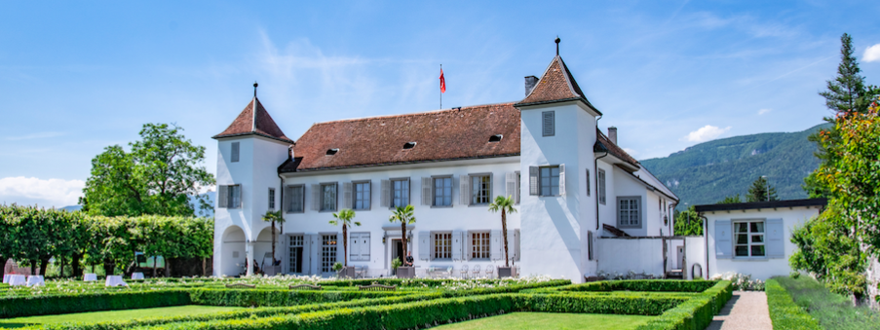

Kick-Off W.A. de Vigier Awards
50 Startups Pitch in One Day

Solothurn, February 9, 2023 The foundation behind Switzerland's most traditional startup award picked 50 startups to enter the race for one of up to five coveted awards. February 23 is Selection Day, where the young companies pitch their ideas in front of the Foundation Board, investors, selected guests and an online audience. Fifteen startups will advance to the next round, and up to five will receive CHF 100,000 each at the award ceremony in June.

"The high quality among the 310 applications impressed the jury. Almost a third of the 50 selected startups are led by women, and it is our goal to further increase the number of female applicants. We also received submissions from companies without any university affiliation, which is a second target group we hope to engage more in the future," says Carmen Lamparter, COO of the W.A. de Vigier Foundation.

This year, there will once again be a live audience at the Kulturfabrik Kofmehl in Solothurn. To give the startups maximum visibility, the foundation will also livestream the event at www.devigier.ch.

Seven industry clusters represented

The wide range of industries represented is also exciting: Life Sciences/Biotech & Pharma, Cleantech, Medtech, ICT, Micro- & Nanotechnology, Services, and Interdisciplinary companies. Each startup is assigned to one of these seven industry clusters and will have three minutes to present its project. After the event, the jury will select its Top 15, which will be further evaluated in the following weeks. From these Top 15, the ten best are then selected. The finalists will present their companies at the Award Ceremony on June 20, 2023.

About the W.A. de Vigier Awards

The W.A. de Vigier Award is the oldest award for young entrepreneurs in Switzerland and, with annual prize money of up to CHF 500,000 (five times CHF 100,000), is one of the most highly endowed startup prizes in Switzerland. Over the past 34 years, the foundation has distributed over CHF 11 million of seed money. The results are over 100 flourishing startups, successful IPOs, multiple company exits and above all, many newly created jobs.

The following aspects are relevant for the evaluation of the projects: The entrepreneurial personality, the degree of innovation, the value for society as a whole, the technical and financial viability, market prospects and the potential for job creation.

###

Contact details for questions
W.A. de Vigier Foundation
Carmen Lamparter, COO
Untere Steingrubenstrasse 25 | 4500 Solothurn | +41 79 799 55 28
carmen.lamparter@devigier.ch | www.devigier.ch

