Press Release

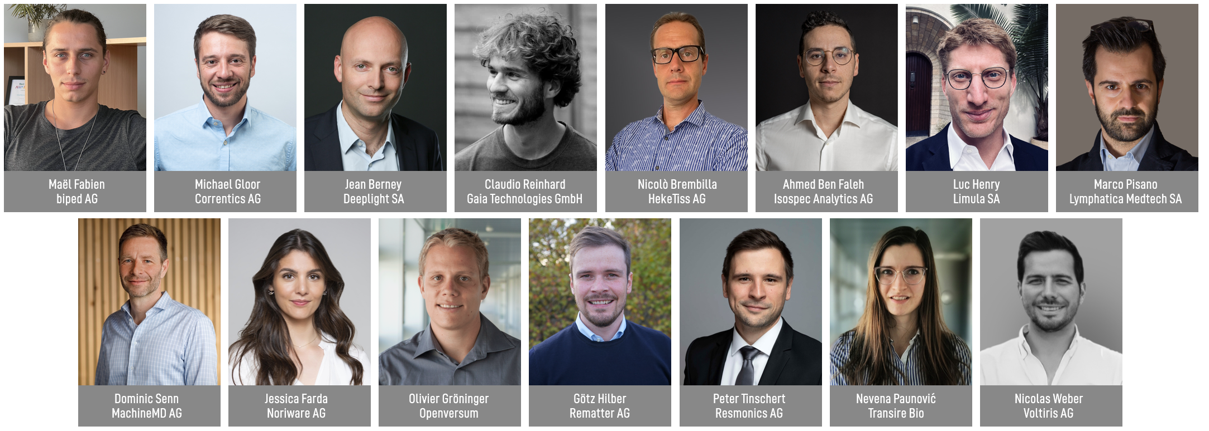

W.A. de Vigier Awards 2023
15 Startups Set Out to Win CHF 100,000

Solothurn, March 29, 2023 15 startups are one lap further in the race for one of up to five coveted W.A. de Vigier Awards. The startups were selected from among 50 young companies who presented their ideas to the foundation board, a live audience and online viewers on Selection Day in mid-February. Up to five Swiss entrepreneurs will receive CHF 100,000 each at the award ceremony on June 20, 2023.

On Selection Day on February 23, the Top 15 were chosen from among 50 pre-selected startups. A record number of over 300 applications were submitted.

"We were so excited to host this event in person at Kulturfabrik Kofmehl in Solothurn. The atmosphere was great and the audience as well as the jury were very impressed with the pitches by these young, brilliant entrepreneurs“, says Carmen Lamparter, COO of the W.A. de Vigier Foundation. „During the pandemic, we started live streaming our main events. We decided to keep doing so, because we want to offer these 50 startups maximum visibility, both nationally and internationally“, continues Lamparter.

The Top 15 will now be further assessed through in-depth interviews with the foundation board as well as expert reports. The Top 10 are subsequently selected during two presentation days. In mid May, the ten finalists will be chosen and are going to present their highly innovative ideas at the award ceremony on June 20, 2023.

These are the Top 15 (in alphabetical order)

biped AG from Epalinges (VD)
Independence for the Visually Impaired
270 million visually impaired people worldwide face challenges in their daily mobility, like avoiding obstacles and finding their way. biped is a small harness, worn on the shoulders, equipped with cameras. Just like a self-driving car, it can detect and predict all obstacles and play a short “beep” in bluetooth headphones to warn the user. biped is on a mission to support visually impaired people to spend time outdoors stress-free, and ultimately help them discover new places independently.
Correntics AG from Zurich (ZH)
Mitigating Risks in the Supply Chain
Climate change and weather extremes cause costly disruptions in global supply chains. With its climate-risk analytics software, Correntics AG predicts both physical and financial risks in supply chains and identifies mitigation and adaptation measures to inform tactical and strategic decisions. This solution is highly valuable for decision makers in business as well as governmental agencies to make data-driven adjustments. Climate-resilient supply chains are a big competitive advantage by ensuring business continuity in complex value chains.

Deeplight SA from Lausanne (VD)
High-Performance Lasers on a Chip
Today, many applications require high performance lasers to sense the environment. Deeplight develops and manufactures high-end lasers that are small, consume very little power and come at a low production cost. Deeplight lasers serve several multi-billion-dollar markets and can be applied to long-range monitoring of infrastructures (aircrafts, telecommunication networks, bridges), long-range sensing of chemicals (methane spills in oil fields) or long-range sensing of objects (automotive industry).

Gaia Technologies GmbH from Berne (BE)
Turning Agro-Waste into Valuable Ingredients
Agricultural waste contains a plethora of resources that could replace synthetic compounds used in the cosmetic and food industries, however, this waste mostly gets discarded without being valorized. ETH-spinoff Gaia Technologies is building scalable solutions to enable the industry to replace harmful chemicals with renewable biocompounds. The core of their IP is a fully biodegradable sorbent that can be regenerated several times before serving as soil amendment.

HekeTiss AG from Plan-les-Ouates (GE)
Healing Chronic Wounds with Stem Cell Skin Patches
More than 3 million people in the EU and US alone suffer from severe chronic wounds that do not respond to conventional therapies. HekeTiss has developed TrophiPatch, a skin patch that incorporates fat-derived stem cells obtained from healthy donors, modified through a proprietary technology to increase their healing potential. TrophiPatch works by restoring a functional wound vasculature, a requirement for achieving superior healing in severe patients. This product revolutionizes the field of chronic wound care by improving patients' quality of life while reducing the economic burden on healthcare systems.

Isospec Analytics AG from Denens (VD)
Empowering Biotechnology Through Molecular Intelligence
The analysis of molecules represents most of the workload in clinical labs and is key to early disease diagnosis. However, current databases only cover a small fraction of known molecules, which leads to a high percentage of ambiguous results. By using the vibrations of a molecule as a unique fingerprint, Isospec can conclusively assign a molecule’s structure via a proprietary database that the EPFL-spinoff develops. This enables the discovery of new disease biomarkers, accelerates the development of therapeutics, and transforms the future of clinical nutrition.

Limula SA from La Tour-de-Peilz (VD)
Cell and Gene Therapy Made Easy
Cell and Gene Therapies (CGT) can save the lives of people with previously incurable conditions, including aggressive cancers. Unfortunately, the production of these highly personalized ‘living drugs’ is still so complex and expensive that only a small fraction of eligible patients has access to a treatment. Limula is developing a fully automated device that enables manufacturing of high-quality cell therapies at lower costs, on demand and at scale, with the potential to dramatically increase their accessibility.

Lymphatica Medtech SA from Lausanne (VD)
An Implant to Successfully Treat Lymphedema Patients
As cancer treatments get better at saving lives, a disabling side effect is gaining attention: Lymphedema is the chronic and painful swelling of one limb, due to the accumulation of liquid under the skin. No cure is available today, only massages, bandages or ineffective surgeries. Lymphatica engineered LymphoDrain, an implant to replace the function of the damaged lymphatic vessels via a subcutaneous micropump/catheter-based drainage system, controlled by a wearable device. This solution allows cancer survivors to recover from Lymphedema and drastically improve their quality of life.

MachineMD AG from Berne (BE)
Improving the Early Diagnosis of Brain Disorders
Brain diseases need to be treated as early as possible to prevent irreversible damage. Instead, patients face long wait times for appointments, examinations aren’t automated, and the diagnosis is often not accurate. MachineMD is developing neos®, a fully automated non-invasive diagnostic device that will measure eye and pupil movements – important biomarkers to diagnose neurological disorders. Eight neuro-ophthalmic examinations will be performed within ten minutes. Today’s manual examination that takes about 45 minutes. neos® can be operated by medical assistants, and the analysis will be possible via telemedical services.

Noriware AG from Gipf-Oberfrick (AG)
Flexible Packaging Made from Seaweed
90% of manufactured plastic is not being recycled and ends up as microplastic in the environment. In collaboration with ETH and FHNW, the HSG-spinoff Noriware developed a seaweed-based packaging film that is made entirely of natural materials. The growth of the raw material seaweed creates a negative carbon footprint, with the final product being home-compostable within a revolutionary time and therefore leaving no residual waste behind.

Openversum from Schlieren (ZH)
Saving Lives with Clean Drinking Water
Today, two billion people do not have access to safe drinking water. Openversum provides a business blueprint to water entrepreneurs and enables them to manufacture and sell drinking water filters locally. The startup’s novel membrane filter is highly efficient, cost-effective and quickly removes pathogens, heavy metals, and micropollutants from water. The company’s microfranchising ecosystem and operational platform allows for fast scaling in order to improve millions of lives.

Rematter AG from Zug (ZG)
Fully Recyclable Floor Slabs Made by Robots
Construction accounts for 50% of resource consumption and 37% of CO2 emissions globally. Rematter’s floor slab system uses widely available, locally sourced, low carbon materials – earth and timber – that are 100% recyclable. Robotic fabrication ensures competitive pricing and high, consistent quality. This allows builders to minimize the environmental impact of their buildings, while maximizing performance and room climate quality.

Resmonics AG from Zurich (ZH)
Acoustic AI to Analyze Lung Symptoms
Respiratory tract infections account for more than 4 million deaths per year, roughly 8% of all deaths. Resmonics offers artificial intelligence that uses microphones of smart devices to detect and analyze lung symptoms. It can detect first signs of disease deterioration and estimate the risk of contracting a lung infection in rooms at any given time. This AI system is available as a software for smartphones and as a smart sensor station in corporate buildings.

Transire Bio from Zurich (ZH)
Painless Delivery of Injectable Drugs
Each day, millions of patients have to administer their medicines through painful injections. Many drugs cannot be taken orally and have to be injected because they are sensitive to degradation and/or too large to cross the gut. This ETH-spinoff takes needles out of the picture and offers a painless alternative for the delivery of these medicines. The technology is based on an octopus-inspired suction patch that patients place on the inner side of the cheek, enabling the drug to efficiently reach the bloodstream. This unique solution removes a huge burden from patients’ lives and from our healthcare systems.

Voltiris AG from Lausanne (VD)
Solar Modules to Combine Energy and Crop Production
Greenhouses require significant amounts of energy and growers are halting operations because of rising energy prices. They want to produce solar energy but current solutions reduce crop yields by shading them. Voltiris’ color-optimized solar modules filter sunlight and transmit only the components needed for photosynthesis to crops, while producing solar energy with the unused light. This enables the production of renewable energy without impacting crop yields and ultimately allows growers to keep producing the food we all need.

About the W.A. de Vigier Awards

The W.A. de Vigier Award is the oldest award for young entrepreneurs in Switzerland and, with annual prize money of up to CHF 500,000 (five times CHF 100,000), is one of the most highly endowed startup prizes in Switzerland. Over the past 34 years, the foundation has distributed over CHF 14 million of seed money. The results are over 100 flourishing startups, successful IPOs, multiple company exits and above all, many newly created jobs.

The following aspects are relevant for the evaluation of the projects: The entrepreneurial personality, the degree of innovation, the value for society as a whole, the technical and financial viability, market prospects and the potential for job creation.
###
Contact details for questions
W.A. de Vigier Foundation
Carmen Lamparter, COO
Untere Steingrubenstrasse 25 | 4500 Solothurn | +41 79 799 55 28
carmen.lamparter@devigier.ch | www.devigier.ch

