Press Release

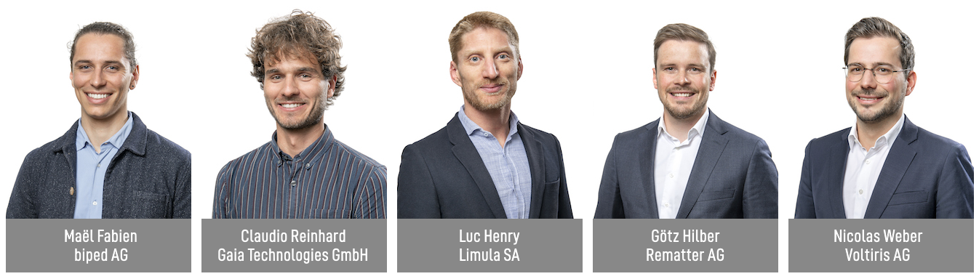

W.A. de Vigier Awards 2023
Three Out of Five Winners Are Cleantech Startups

Solothurn, June 20, 2023. At his year’s Award Ceremony on June 20, the guests and the ten nominated startups had the great honor of being greeted by Federal Councillor Viola Amherd. Five winners received a W.A. de Vigier Award, each prize is endowed with CHF 100,000.00. The winning projects range from AI harnesses for the visually impaired, to manufacturing devices for personalized drugs, as well as sustainable floor slabs.

„The five winners have one thing in common: They all want to make the world a better and more sustainable place by contributing innovative solutions for the greater good of our society “, says Carmen Lamparter, COO of the W.A. de Vigier Foundation.

From a record number of over 300 submitted projects, the jury picked their Top 15 in February. The 15 CEOs went through an interview process and presented their ideas to the Foundation Board, who chose the final ten nominees.

These are the five winners (in alphabetical order)

biped AG from Epalinges (VD)
Independence for the Visually Impaired
270 million visually impaired people worldwide face challenges in their daily mobility, like avoiding obstacles and finding their way. biped is a small harness, worn on the shoulders, equipped with cameras. Just like a self-driving car, it can detect and predict all obstacles and play a short “beep” in bluetooth headphones to warn the user. biped is on a mission to support visually impaired people to spend time outdoors stress-free, and ultimately help them discover new places independently.

Gaia Technologies GmbH from Berne (BE)
Turning Agro-Waste Into Valuable Ingredients
Agricultural waste contains a plethora of resources that could replace synthetic compounds used in the cosmetic and food industries, however, this waste mostly gets discarded without being valorized. ETH-spinoff Gaia Technologies is building scalable solutions to enable the industry to replace harmful chemicals with renewable biocompounds. The core of their IP is a fully biodegradable sorbent that can be regenerated several times before serving as soil amendment.

Limula SA from La Tour-de-Peilz (VD)
Cell and Gene Therapy Made Easy
Cell and Gene Therapies (CGT) can save the lives of people with previously incurable conditions, including aggressive cancers. Unfortunately, the production of these highly personalized ‘living drugs’ is still so complex and expensive that only a small fraction of eligible patients has access to a treatment. Limula is developing a fully automated device that enables manufacturing of high-quality cell therapies at lower costs, on demand and at scale, with the potential to dramatically increase their accessibility.

Rematter AG from Zug (ZG)
Fully Recyclable Floor Slabs Made by Robots
Construction accounts for 50% of resource consumption and 37% of CO2 emissions globally. Rematter’s floor slab system uses widely available, locally sourced, low carbon materials – earth and timber – that are 100% recyclable. Robotic fabrication ensures competitive pricing and high, consistent quality. This allows builders to minimize the environmental impact of their buildings, while maximizing performance and room climate quality.

Voltiris AG from Lausanne (VD)
Solar Modules to Combine Energy and Crop Production
Greenhouses require significant amounts of energy and growers are halting operations because of rising energy prices. They want to produce solar energy but current solutions reduce crop yields by shading them. Voltiris’ color-optimized solar modules filter sunlight and transmit only the components needed for photosynthesis to crops, while producing solar energy with the unused light. This enables the production of renewable energy without impacting crop yields and ultimately allows growers to keep producing the food we all need.

About the W.A. de Vigier Awards

The W.A. de Vigier Award is the oldest award for young entrepreneurs in Switzerland and, with annual prize money of up to CHF 500,000 (five times CHF 100,000), is one of the most highly endowed startup prizes in Switzerland. Over the past 34 years, the foundation has distributed almost CHF 14 million of seed money. The results are well over 100 flourishing startups, successful IPOs, multiple company exits and above all, many newly created jobs.
The following aspects are relevant for the evaluation of the projects: The entrepreneurial personality, the degree of innovation, the value for society as a whole, the technical and financial viability, market prospects and the potential for job creation.
###
Contact details for questions
W.A. de Vigier Foundation
Carmen Lamparter, COO
Untere Steingrubenstrasse 25 | 4500 Solothurn | +41 79 799 55 28
carmen.lamparter@devigier.ch | www.devigier.ch

