Press Release

W.A. de Vigier Foundation
Dr. Theresa Visarius Appointed as New Member of the Foundation Board

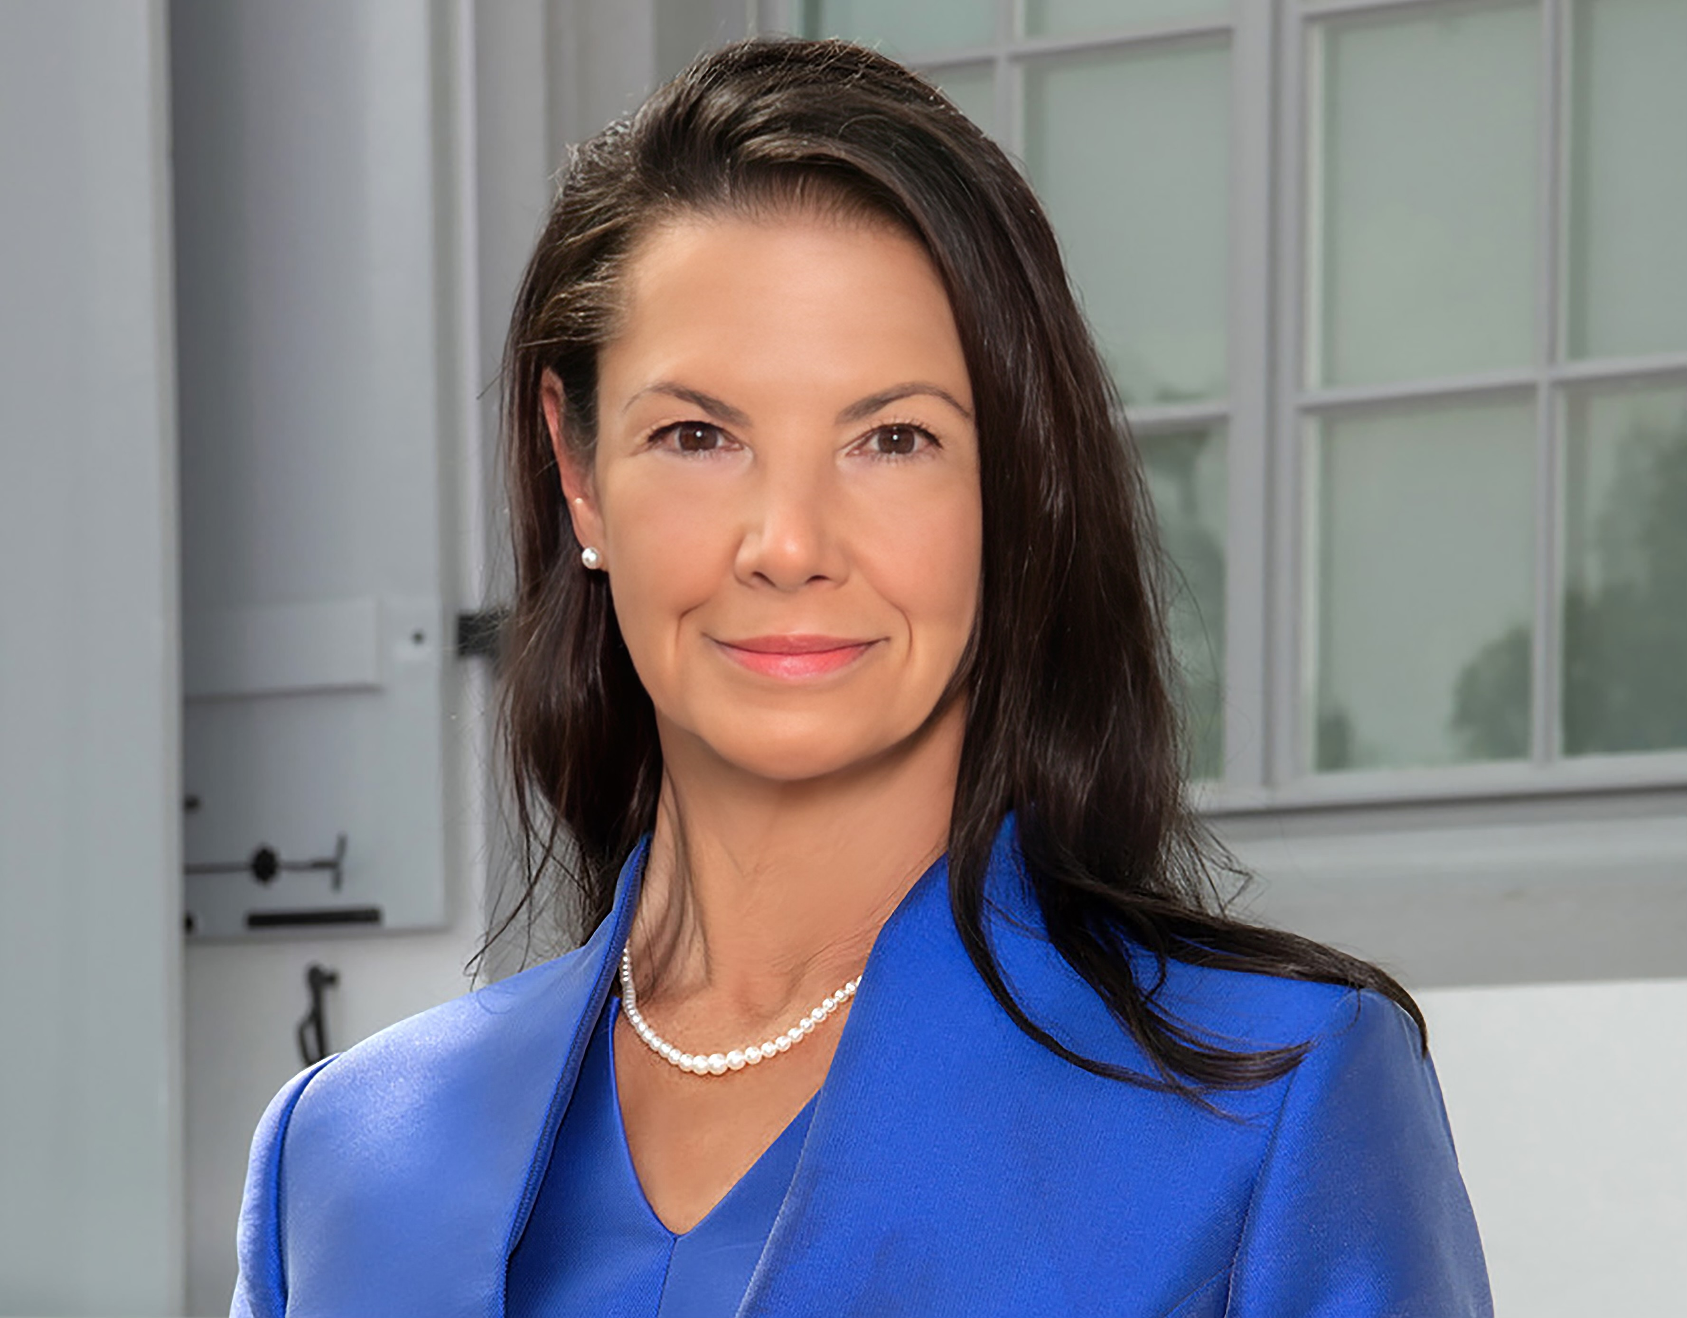

September 7, 2023. The W.A. de Vigier Foundation, which awards one of the most highly endowed prizes for young entrepreneurs in Switzerland, has a new board member. As of July 1, 2023, Dr. Theresa Visarius succeeds retiring Board Member Lic. Iur. Sven Hoffmann who has been dedicated to the institution since 2005. The board is comprised of highly skilled and reputable individuals with a wide range of expertise who build consensus to serve the mission of the W.A. de Vigier Foundation.

Dr. Theresa Visarius adds to the competences of the de Vigier Board through her deep knowledge in science and business experience. She holds degrees in Chemistry and Biology from the USA and a Ph.D. in Pharmacology from the University of Berne. Dr. Visarius spent the first part of her career in academia before crossing over into innovation. She is currently Vice President of Business Development at Immunophotonics, Inc., (USA) and Managing Director of Immunophotonics’ European Headquarters (Berne, Switzerland). She and her team are pioneering an innovative way to engage the immune system to fight cancer in a field they call Interventional Immuno-Oncology with clinical trials open in Switzerland, USA, UK, France, and Germany. Additionally, Dr. Visarius is a member of the Nobel Sustainability Trust Award committee and a startup coach for the Canton of Berne.
Commenting on her new role, Dr. Visarius says “Joining the W.A. de Vigier Board is an honor that means a great deal to me. Understanding first-hand what is required to translate innovative ideas into meaningful products and businesses, I could not be more aligned with this foundation’s vision. I welcome the opportunity to leverage my knowledge and network to contribute to the board’s mission of identifying and supporting highly promising Swiss entrepreneurs."

André Hoffmann, President of the Board, extends a warm welcome to Dr. Theresa Visarius: "We consider ourselves fortunate to add someone of her caliber to our board. With her expertise spanning the realms of science, innovation, leadership, and business, we are confident that her contributions will profoundly enrich our board's work."

The W.A. de Vigier Award is the oldest award for young entrepreneurs in Switzerland and annually awards up to CHF 500,000 (five times CHF 100,000). Over the past 34 years, the foundation has distributed almost CHF 14 million in seed capital. The results are well over 100 flourishing startups, successful IPOs, multiple company exits and many newly created jobs.
The following aspects are relevant for the evaluation of projects submitted to the Foundation: entrepreneurial personality, degree of innovation, value for society as a whole, technical and financial viability, market prospects and the potential for job creation.

###
Contact
W.A. de Vigier Foundation
Carmen Lamparter, COO
Untere Steingrubenstrasse 25 | 4500 Solothurn | +41 79 799 55 28
carmen.lamparter@devigier.ch | www.devigier.ch

