Press Release

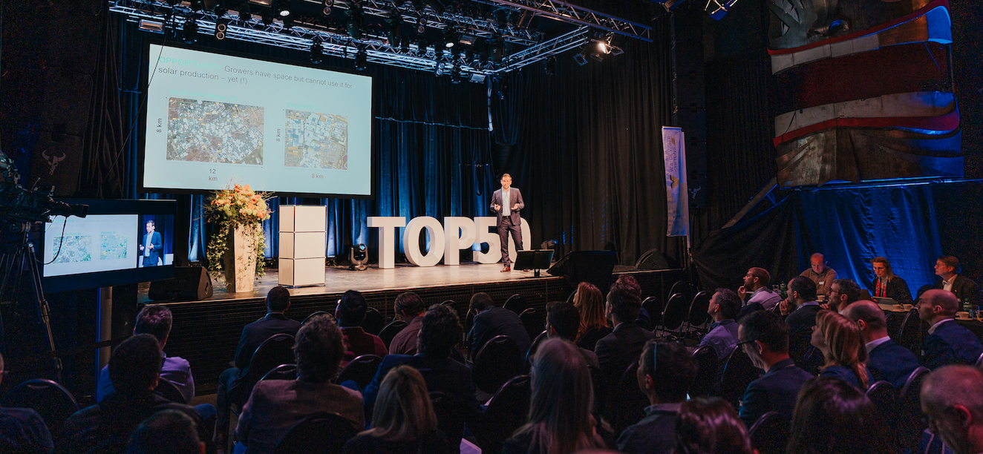

Kick-Off W.A. de Vigier Awards
50 Startups Pitch in One Day

Solothurn, February 21, 2024. The foundation behind one of Switzerland's most prestigious startup awards is hosting its annual Selection Day in Solothurn on February 28, where 50 young entrepreneurs will pitch their innovative ideas to the Foundation Board, investors, guests, and viewers online. The jury will pick 15 startups to progress to the next stage, with up to five companies ultimately receiving CHF 100,000 each at the grand award ceremony slated for June.

"The jury was impressed by the exceptional quality and diversity of the applications, ultimately selecting 50 highly competitive startups out of over 200 submissions. We are looking forward to an exciting showcase of Swiss innovation", says Carmen Lamparter, COO of the W.A. de Vigier Foundation.

To give the startups maximum visibility, the foundation is livestreaming the event at www.devigier.ch.

Startups from eight industries

The W.A. de Vigier Foundation supports promising startups across all industries. This year’s clusters are Life Sciences, Biotech and Pharma, Cleantech, Medtech, ICT, Interdisciplinary and Services. Each startup is assigned to one of these clusters and has three minutes to pitch its project. After the event, the jury will select its Top 15, which will be further evaluated in the following weeks. From these Top 15, the ten best are selected. The finalists will present their companies at the Award Ceremony on June 19, 2024.

About the W.A. de Vigier Awards

The W.A. de Vigier Award is the oldest award for young entrepreneurs in Switzerland and, with annual prize money of up to CHF 500,000 (five times CHF 100,000), is one of the most highly endowed startup prizes in Switzerland. Over the past 35 years, the foundation has distributed over CHF 14 million of seed money. The results are over 100 flourishing startups, successful IPOs, multiple company exits and above all, many newly created jobs.

The following aspects are relevant for the evaluation of the projects: The entrepreneurial personality, the degree of innovation, the value for society as a whole, the technical and financial viability, market prospects and the potential for job creation.

###

Contact details for questions
W.A. de Vigier Foundation
Carmen Lamparter, COO
Untere Steingrubenstrasse 25 | 4500 Solothurn | +41 79 799 55 28
carmen.lamparter@devigier.ch | www.devigier.ch

