Press Release

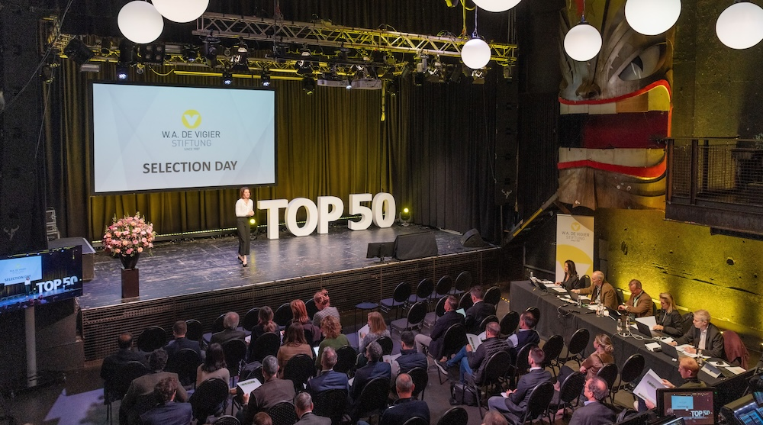

Kick-Off W.A. de Vigier Awards
50 Startups, One Day, One Shot at CHF 120 000

Solothurn, February 25, 2026 – The W.A. de Vigier Foundation, which presents Switzerland's oldest and most prestigious startup award, is hosting its annual Selection Day on March 3 at the Kulturfabrik Kofmehl in Solothurn. 50 of Switzerland's most promising startups will each have three minutes to pitch their ideas to the jury, investors, a live audience and viewers online.

The competition spans a broad range of industries, including Life Sciences, Biotech & Pharma, Cleantech, Medtech, Micro- & Nanotechnology, ICT, Interdisciplinary, and Services. Each startup has three minutes to make its case. After the event, the jury will select 15 companies to advance to the next rounds, ultimately narrowing the field to up to five winners, each receiving CHF 120 000 in non-dilutive funding at the grand Award Ceremony on June 10, 2026.

Unmatched Visibility for Swiss Startups

To ensure maximum exposure, the foundation will livestream the entire event at www.devigier.ch, allowing audiences across the globe to witness Switzerland’s next wave of entrepreneurial talent in action.

"Selection Day is curated startup scouting at its finest," says Céline Bedu, COO of the W.A. de Vigier Foundation. "In a single day, 50 carefully selected startups from a wide range of industries present their ideas – challenged by the sharp questions of an experienced jury. For investors and decision-makers, it's an unparalleled overview of the best Swiss startup talent right now."
For more information and to watch the event live, visit www.devigier.ch.

About the W.A. de Vigier Awards

The W.A. de Vigier Award is the oldest award for young entrepreneurs in Switzerland and also one of the most highly endowed Swiss startup prizes. Over the past 39 years, the foundation has distributed
CHF 15.6 million of seed money to over 160 young ventures. The results are flourishing startups, successful IPOs, multiple company exits and above all, many newly created jobs.

Thanks to the continued support of our funding partner FERS, the total prize money will reach up to
CHF 700,000 this year, further strengthening the award's impact on Switzerland's startup ecosystem.

The following aspects are relevant for the evaluation of the projects: The entrepreneurial personality, the degree of innovation, the value for society as a whole, the technical and financial viability, market prospects and the potential for job creation.

###

Contact details for questions
W.A. de Vigier Foundation
Céline Bedu, COO
Untere Steingrubenstrasse 25 | 4500 Solothurn
celine.bedu@devigier.ch | www.devigier.ch

