Press Release

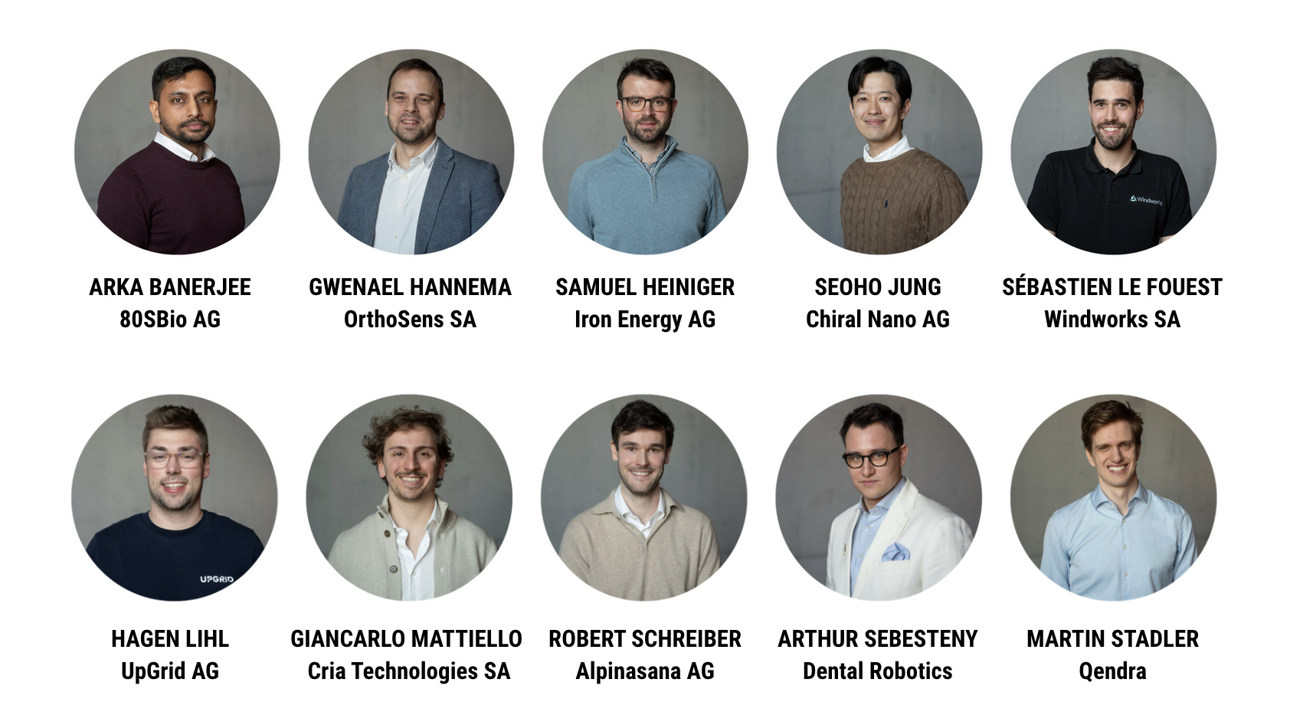

2026 W.A. de Vigier Awards
The W.A. de Vigier Foundation Announces Its Top 10 Nominees

Solothurn, May 12, 2026 – On June 10, the W.A. de Vigier Foundation will bring together Switzerland's most promising entrepreneurial talent for its annual Award Ceremony, and by the end of the evening, up to five exceptional founders will have earned one of the country's most coveted startup prizes, each endowed with CHF 120 000.

Ten nominated startups will take the stage before an invited audience, each presenting their venture to the Foundation's jury. Among the evening's highlights: a keynote address from Dorian Selz, CEO of Squirro and W.A. de Vigier Award winner of 2010. The ceremony can be followed live at www.devigier.ch.

From over 200 submitted projects, the jury first selected the Top 50 and then a Top 15 in February, each of whom then underwent an in-depth interview process with the Foundation Board. The ten finalists taking the stage on June 10 earned their place through every round.

Reaching this stage required more than a strong idea — and that is by design. At the W.A. de Vigier Foundation, the CEOs’ personalities weigh just as much as the business case. "It often takes more than just one look to identify founders who strike the right balance between a compelling project and an equally strong entrepreneurial mindset," says Céline Bedu, COO of the W.A. de Vigier Foundation.

The Top 10, in alphabetical order

Arka Banerjee / 80SBio AG / Basel (BS)
Point-of-care molecular diagnostics for infectious diseases
Access to reliable diagnostic testing remains limited in many parts of the world, forcing clinicians to treat infectious diseases without knowing the exact cause. 80SBio develops QuantR, a point-of-care system that brings lab-grade molecular testing directly to patients. Using its UniqRT chemistry, the technology runs parallel RT-qPCR directly from raw patient samples, removing complex preparation steps. A low-cost cartridge and compact reader allow healthcare workers to load a finger-prick sample and test for multiple infectious diseases at once. This enables fast, affordable diagnostics and helps clinicians deliver the right treatment even in low-resource settings.

Gwenael Hannema / OrthoSens SA / Biel (BE)
Sensors that track healing after orthopedic surgery
Orthopedic recovery is often monitored through occasional X-rays and patient self-reports, which can detect complications too late. OrthoSens turns standard orthopedic implants into connected devices that measure healing in real time. A tiny battery-free sensor inside the implant is powered by an external wearable and streams data on load, micro-motion risk, and bone fusion to the SensApp. Surgeons and physiotherapists can track recovery through clear dashboards, while patients follow progress at home, enabling earlier interventions and reducing avoidable imaging, hospital visits, and revision surgeries.

Samuel Heiniger / Iron Energy AG / Zurich (ZH)
Long-duration energy storage using iron oxide
Renewable energy from solar and wind is produced when the sun shines or the wind blows, not necessarily when electricity is needed. This creates a growing need for large-scale, low-cost energy storage to balance supply and demand over longer periods, including across seasons. Iron Energy develops a storage technology that converts surplus electricity into hydrogen and stores it in iron. The hydrogen reduces iron oxide to metallic iron, allowing energy to be stored safely and cheaply. When electricity is needed again, the iron is oxidized with steam, producing hydrogen that can be converted back into electricity.

Seoho Jung / Chiral Nano AG / Dübendorf (ZH)
Post-silicon semiconductors with nanomaterials
The semiconductor industry is approaching the physical limits of silicon while demand for computing power continues to grow. Nanomaterials such as carbon nanotubes promise faster and more energy-efficient transistors, but existing production methods cannot scale to industrial manufacturing. Chiral Nano develops equipment that integrates nanomaterials into chips with high precision. Its patented process grows high-quality nanomaterials, selects the best structures using automated microscopy and AI, and transfers them robotically onto wafers. This enables semiconductor manufacturers to build post-silicon chips for future technologies such as AI and quantum computing.

Sébastien Le Fouest / Windworks SA / Lausanne (VD)
Smart vertical-axis wind turbines to generate local power
Wind energy remains underused in many regions as large wind farms face long approval processes, high infrastructure costs, and local opposition. At the same time, farms, municipalities, and small businesses investing in solar power face electricity shortages in winter and at night. Windworks develops compact vertical-axis turbines for on-site power generation. Its key innovation is real-time blade pitch control: each blade adjusts its orientation using onboard sensors and a proprietary algorithm that adapts to changing wind conditions, increasing energy yield and turbine lifetime. Quiet systems under 30 meters can typically be permitted within a year.

Hagen Lihl / UpGrid AG / Baar (ZG)
Software to connect and manage local renewable energy
As more homes and businesses install solar panels, electricity is increasingly produced locally. But today’s energy markets are not designed to manage this local, decentralized production efficiently. UpGrid develops a software platform that connects solar systems, batteries, and other local energy assets. The platform helps households, companies, and energy providers control when electricity is used, stored, or sold. By automating trading, billing, and coordination, UpGrid allows locally produced energy to be used more efficiently. This increases self-consumption, stabilizes prices, and makes renewable energy investments more attractive.

Giancarlo Mattiello / Cria Technologies SA / Plan-les-Ouates (GE)
High-vacuum containers for reliable transport of sensitive biological materials
Modern therapies such as cell and gene treatments, IVF samples, stem cells, and advanced diagnostics require extremely stable temperature conditions during transport. Yet many shipments still rely on dry ice, which is difficult to handle and prone to temperature fluctuations that can compromise valuable therapies. Crìa Technologies develops high-vacuum insulated containers that dramatically reduce heat transfer. Its first product, Crìa Go, is shoulder-carriable, cabin-compatible, and operates with reusable ice packs instead of dry ice. It offers cryogenic-level performance while remaining simple to ship with standard couriers.

Robert Schreiber / Alpinasana AG / Zurich (ZH)
Early detection and targeted nutrition to combat malnutrition
Malnutrition is a widespread but often overlooked problem in healthcare: up to 30% of hospital patients and more than half of elderly people are affected, leading to serious health complications and high healthcare costs. Alpinasana addresses this challenge with a combined digital and nutritional approach. Its AI-based system analyzes meal trays in hospitals to identify patients at risk of malnutrition at an early stage. These patients can then receive specially developed medical nutrition products designed to provide balanced nutrition and encourage regular use through good taste and variety. By helping caregivers detect and address malnutrition earlier, Alpinasana aims to improve patient outcomes while reducing healthcare costs.

Arthur Sebesteny / Dental Robotics
Portable system for preventive dental care anywhere
Oral diseases affect more than 3.5 billion people worldwide and are linked to serious chronic conditions, yet preventive dental care is often difficult to access. Many patients avoid regular visits due to travel, waiting times, or fear of clinical environments. Dental Robotics addresses this challenge with an ultra-portable 3-in-1 dental hygiene system and digital platform that enables professional care outside traditional clinics. Hygienists can deliver preventive treatments in homes, workplaces, and care facilities. By bringing dental care closer to patients, Dental Robotics aims to improve access, encourage regular check-ups, and support better long-term oral and overall health.

Martin Stadler / Qendra
Control technology addressing a key bottleneck in quantum computing
Quantum computers promise major advances in areas such as drug discovery, materials science, and secure communication. However, building and operating these machines remains extremely complex. Many quantum computers rely on individual atoms that must be controlled with extraordinary precision using specialized electronics and software. Current control systems are often difficult to set up and require extensive customization, slowing research and development. Qendra addresses this challenge with an integrated hardware and software platform designed specifically for these atomic-scale quantum systems. By simplifying system control and improving stability, Qendra helps researchers run experiments more efficiently and accelerate the development of practical quantum computers.

About the W.A. de Vigier Awards

The W.A. de Vigier Award is the oldest award for young entrepreneurs in Switzerland and also one of the most highly endowed Swiss startup prizes. Over the past 39 years, the foundation has distributed
CHF 15.6 million of seed money to over 160 young ventures. The results are flourishing startups, successful IPOs, multiple company exits and above all, many newly created jobs.

Thanks to the continued support of our funding partner FERS, the total prize money will reach up to
CHF 700,000 this year, further strengthening the award's impact on Switzerland's startup ecosystem.

The following aspects are relevant for the evaluation of the projects: The entrepreneurial personality, the degree of innovation, the value for society as a whole, the technical and financial viability, market prospects and the potential for job creation.

###

Contact details for questions
W.A. de Vigier Foundation
Céline Bedu, COO
Untere Steingrubenstrasse 25 | 4500 Solothurn
celine.bedu@devigier.ch | www.devigier.ch

